Team name: DBeaver

Project name: DBeaver

Feature: DBeaver is a free cross-platform database tool, so a large amount of data needs to be handled in it. Manually inputting data is very cumbersome. It is necessary to import cvs files into the application directly in real wold. We will choose this feature to understand.

The model of where that feature is located

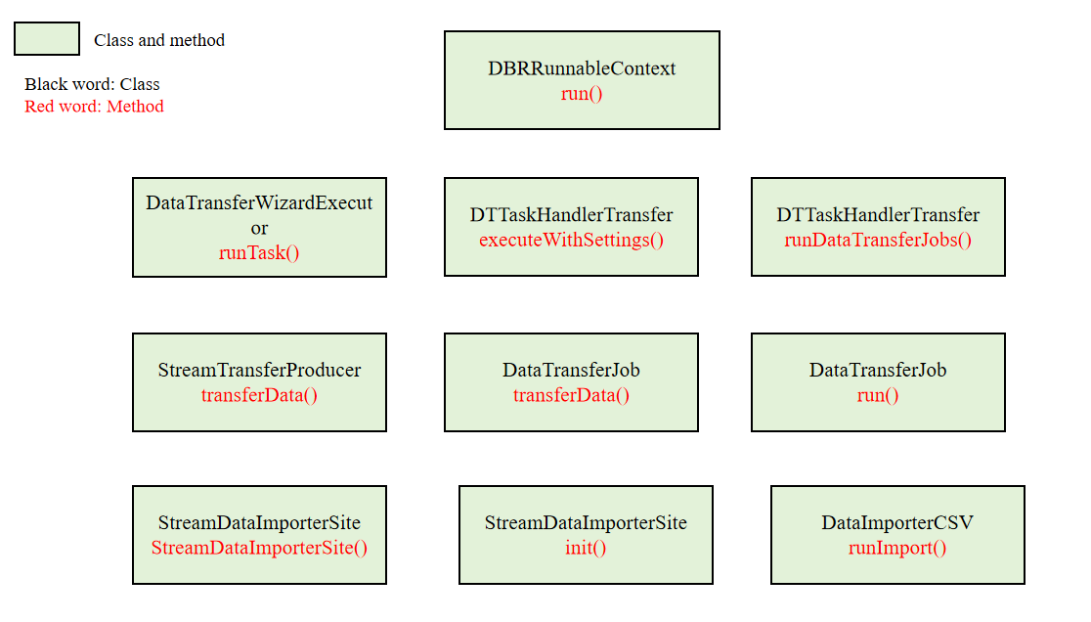

The model of how that feature works

